Geometry Inductive Reasoning

Definition
# Source: AI Source: Provided by: [Data Path: Persons Table -> ID Column: 1, Name_En Column: Motasem Essam] -> From: [ChatGPT] on [7/25/2026]
Geometry Inductive Reasoning is the process of examining specific geometric examples, observations, measurements, or patterns and using them to formulate a general conjecture or rule.
It moves from specific observations to a general conclusion.
$$\boxed{\text{Examples / Observations}→\text{Pattern}→\text{Conjecture}}$$
Unlike deductive reasoning, inductive reasoning generally suggests that a statement is true; it does not by itself establish that the statement must be true for every possible case.

Simple Definition
# Source: AI Source: Provided by: [Data Path: Persons Table -> ID Column: 1, Name_En Column: Motasem Essam] -> From: [ChatGPT] on [7/25/2026]
Geometry Inductive Reasoning means looking at several geometric examples, identifying a pattern, and forming a general statement that appears to explain the pattern.
Example
Suppose several triangles are examined:
$${40}^{∘}+{60}^{∘}+{80}^{∘}={180}^{∘} \\ {50}^{∘}+{70}^{∘}+{60}^{∘}={180}^{∘} \\ {90}^{∘}+{30}^{∘}+{60}^{∘}={180}^{∘}$$
The repeated pattern suggests the conjecture:
$$\boxed{\text{The angles of every triangle add to }{180}^{∘}}$$
The examples lead to the conjecture. A deductive proof is then required to establish the theorem.

Fundamental Concept
# Source: AI Source: Provided by: [Data Path: Persons Table -> ID Column: 1, Name_En Column: Motasem Essam] -> From: [ChatGPT] on [7/25/2026]
Inductive reasoning follows this general process:
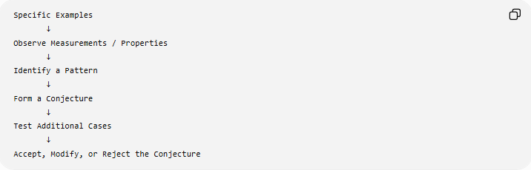
Specific Examples
↓
Observe Measurements / Properties
↓
Identify a Pattern
↓
Form a Conjecture
↓
Test Additional Cases
↓
Accept, Modify, or Reject the Conjecture
The important point is that the conclusion is a conjecture until it is established by an appropriate proof.

Main Components

1. Observation
# Source: AI Source: Provided by: [Data Path: Persons Table -> ID Column: 1, Name_En Column: Motasem Essam] -> From: [ChatGPT] on [7/25/2026]
The process begins by examining geometric objects or situations.
Examples:
- measuring angles,
- comparing side lengths,
- counting sides,
- observing symmetry,
- calculating areas,
- examining transformations,
- constructing several related figures.

2. Collection of Examples
# Source: AI Source: Provided by: [Data Path: Persons Table -> ID Column: 1, Name_En Column: Motasem Essam] -> From: [ChatGPT] on [7/25/2026]
Multiple examples are considered to determine whether a consistent pattern exists.
For example, the interior-angle sums of polygons can be calculated:
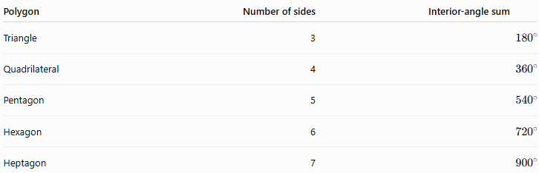
Polygon | Number of sides | Interior-angle sum
Triangle | 3 | $${180}^{∘}$$
Quadrilateral | 4 | $${360}^{∘}$$
Pentagon | 5 | $${540}^{∘}$$
Hexagon | 6 | $${720}^{∘}$$
Heptagon | 7 | $${900}^{∘}$$
A pattern becomes visible.

3. Pattern Recognition
# Source: AI Source: Provided by: [Data Path: Persons Table -> ID Column: 1, Name_En Column: Motasem Essam] -> From: [ChatGPT] on [7/25/2026]
The observed examples are compared to identify a relationship.
For the polygon examples:
$${180}^{∘}, {360}^{∘}, {540}^{∘}, {720}^{∘}, {900}^{∘}$$
Each additional side increases the interior-angle sum by:
$${180}^{∘}$$
This suggests the general formula:
$$\boxed{S=\left(n-2\right){180}^{∘}}$$
where $n$is the number of sides.

4. Conjecture
# Source: AI Source: Provided by: [Data Path: Persons Table -> ID Column: 1, Name_En Column: Motasem Essam] -> From: [ChatGPT] on [7/25/2026]
A conjecture is a statement believed to be true based on observations and patterns but not yet established by proof.
For example:
The sum of the interior angles of an $n$-sided polygon is $\left(n-2\right){180}^{∘}$.
The pattern suggests the formula, but the formula becomes a theorem only after it has been proven.

5. Testing
# Source: AI Source: Provided by: [Data Path: Persons Table -> ID Column: 1, Name_En Column: Motasem Essam] -> From: [ChatGPT] on [7/25/2026]
Additional examples can be examined to see whether they continue to support the conjecture.
For example, for an octagon:
$$S=\left(8-2\right){180}^{∘} \\ S=6\left({180}^{∘}\right) \\ \boxed{S={1080}^{∘}}$$
Testing additional cases increases confidence in the conjecture, but a finite number of successful examples does not generally prove a universal statement.

Inductive Reasoning Process
# Source: AI Source: Provided by: [Data Path: Persons Table -> ID Column: 1, Name_En Column: Motasem Essam] -> From: [ChatGPT] on [7/25/2026]
The overall process can be represented as:
Specific Geometric Examples
↓
Observation
↓
Measurement / Calculation
↓
Pattern Recognition
↓
Conjecture
↓
Test Examples
↙ ↘
Counterexample Supports Pattern
↓ ↓
Reject / Modify Continue Testing
↓
Deductive Proof
↓
Theorem

Types of Geometry Inductive Reasoning
# Source: AI Source: Provided by: [Data Path: Persons Table -> ID Column: 1, Name_En Column: Motasem Essam] -> From: [ChatGPT] on [7/25/2026]
A practical classification is:
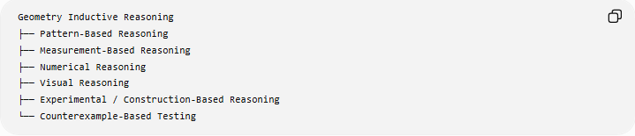
Geometry Inductive Reasoning
├── Pattern-Based Reasoning
├── Measurement-Based Reasoning
├── Numerical Reasoning
├── Visual Reasoning
├── Experimental / Construction-Based Reasoning
└── Counterexample-Based Testing
These categories can overlap.

1. Pattern-Based Inductive Reasoning
# Source: AI Source: Provided by: [Data Path: Persons Table -> ID Column: 1, Name_En Column: Motasem Essam] -> From: [ChatGPT] on [7/25/2026]
Definition
Pattern-Based Inductive Reasoning is the process of examining a sequence of geometric figures, properties, values, or relationships and identifying a repeated pattern that suggests a general rule or conjecture.
The reasoning follows:
$$\boxed{\text{Examples}→\text{Pattern}→\text{General Rule}→\text{Conjecture}}$$
The important feature is that the general rule is discovered from repeated cases.

How It Works
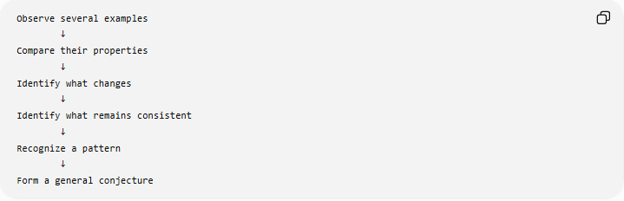
Observe several examples
↓
Compare their properties
↓
Identify what changes
↓
Identify what remains consistent
↓
Recognize a pattern
↓
Form a general conjecture

Example 1: Interior Angles of Polygons
Consider the following polygons:
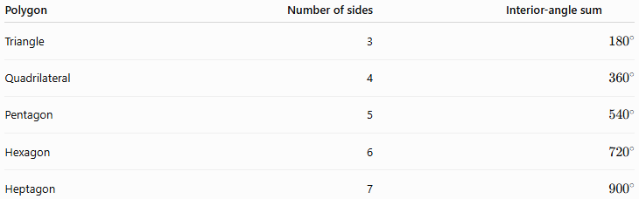
Polygon | Number of sides | Interior-angle sum
Triangle | 3 | $${180}^{∘}$$
Quadrilateral | 4 | $${360}^{∘}$$
Pentagon | 5 | $${540}^{∘}$$
Hexagon | 6 | $${720}^{∘}$$
Heptagon | 7 | $${900}^{∘}$$
Observe the sequence:
$${180}^{∘}, {360}^{∘}, {540}^{∘}, {720}^{∘}, {900}^{∘}$$
Each additional side increases the sum by:
$${180}^{∘}$$
This suggests:
$$S=\left(n-2\right){180}^{∘}$$
Therefore, we form the conjecture:
$$\boxed{S=\left(n-2\right){180}^{∘}}$$
The formula can then be proven deductively.

Example 2: Number of Diagonals
Consider:
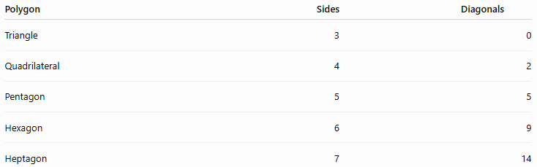
Polygon | Sides | Diagonals
Triangle | 3 | 0
Quadrilateral | 4 | 2
Pentagon | 5 | 5
Hexagon | 6 | 9
Heptagon | 7 | 14
The sequence is:
$$0, 2, 5, 9, 14$$
The differences are:
$$2, 3, 4, 5$$
The pattern suggests:
$$\boxed{D=\frac{n\left(n-3\right)}{2}}$$
Again, this is initially a conjecture discovered through examples.

2. Measurement-Based Inductive Reasoning
# Source: AI Source: Provided by: [Data Path: Persons Table -> ID Column: 1, Name_En Column: Motasem Essam] -> From: [ChatGPT] on [7/25/2026]
Definition
Measurement-Based Inductive Reasoning uses measurements of geometric quantities from several examples to identify a possible relationship and formulate a conjecture.
Measurements may include:
- lengths,
- angles,
- areas,
- perimeters,
- radii,
- diameters,
- distances.
The basic structure is:
$$\boxed{\text{Measure}→\text{Compare}→\text{Identify Relationship}→\text{Conjecture}}$$

Example 1: Triangle Angle Sum
Measure the angles of several triangles.
Triangle 1
$${40}^{∘}, {60}^{∘}, {80}^{∘}$$
Therefore:
$${40}^{∘}+{60}^{∘}+{80}^{∘}={180}^{∘}$$
Triangle 2
$${50}^{∘}, {70}^{∘}, {60}^{∘}$$
Therefore:
$${50}^{∘}+{70}^{∘}+{60}^{∘}={180}^{∘}$$
Triangle 3
$${90}^{∘}, {35}^{∘}, {55}^{∘}$$
Therefore:
$${90}^{∘}+{35}^{∘}+{55}^{∘}={180}^{∘}$$
Repeated measurements suggest:
$$\boxed{A+B+C={180}^{∘}}$$
This observation leads toward the Triangle Sum Theorem.

Example 2: Circle Circumference
Measure the circumference and diameter of several circles.
Suppose the measurements approximately produce:
$$\frac{C}{d}≈3.14$$
for multiple circles.
This suggests:
$$\boxed{C≈πd}$$
and therefore:
$$\boxed{C=2πr}$$
The measurements help reveal the relationship.

Important Limitation
Measurement does not automatically prove an exact mathematical relationship.
For example:
$${59.9}^{∘}≈{60}^{∘}$$
does not by itself prove:
$${59.9}^{∘}={60}^{∘}$$
Measurements provide evidence for a conjecture; deductive reasoning is generally required for mathematical proof.

3. Numerical Inductive Reasoning
# Source: AI Source: Provided by: [Data Path: Persons Table -> ID Column: 1, Name_En Column: Motasem Essam] -> From: [ChatGPT] on [7/25/2026]
Definition
Numerical Inductive Reasoning uses numerical calculations from several geometric examples to discover a sequence, relationship, or formula.
It is particularly useful when geometric properties can be represented numerically.
$$\boxed{\text{Numerical Examples}→\text{Sequence / Relationship}→\text{Formula Conjecture}}$$

Example 1: Polygon Interior-Angle Sums
Calculate:
$$\begin{aligned}n=3&→{180}^{∘} \\ n=4&→{360}^{∘} \\ n=5&→{540}^{∘} \\ n=6&→{720}^{∘}\end{aligned}$$
The differences are:
$${180}^{∘}$$
for each additional side.
This suggests:
$$S=\left(n-2\right){180}^{∘}$$

Example 2: Number of Diagonals
Consider:
$$n=3→0 \\ n=4→2 \\ n=5→5 \\ n=6→9 \\ n=7→14$$
The pattern is:
$$0, 2, 5, 9, 14$$
The successive differences are:
$$2, 3, 4, 5$$
This suggests:
$$D=\frac{n\left(n-3\right)}{2}$$
For $n=8$:
$$D=\frac{8\left(8-3\right)}{2} \\ D=\frac{40}{2} \\ \boxed{D=20}$$
The numerical pattern predicts that an octagon has 20 diagonals.

Example 3: Square Areas
Consider squares with side lengths:
$$1, 2, 3, 4, 5$$
Their areas are:
$$1, 4, 9, 16, 25$$
The numerical pattern is:
$$1^{2}, 2^{2}, 3^{2}, 4^{2}, 5^{2}$$
This suggests:
$$\boxed{A=s^{2}}$$
for a square with side length $s$.

4. Visual Inductive Reasoning
# Source: AI Source: Provided by: [Data Path: Persons Table -> ID Column: 1, Name_En Column: Motasem Essam] -> From: [ChatGPT] on [7/25/2026]
Definition
Visual Inductive Reasoning is the process of examining geometric diagrams, arrangements, transformations, or shapes and recognizing a visual pattern that suggests a general geometric relationship.
The reasoning is primarily based on what is observed in the configuration, rather than on numerical measurements alone.
$$\boxed{\text{Visual Examples}→\text{Visual Pattern}→\text{Conjecture}}$$

Example 1: Angle Bisectors of a Triangle
Construct the three internal angle bisectors of several triangles.
In each diagram, the three angle bisectors appear to meet at one point.
This suggests the conjecture:
$$\boxed{\text{The three internal angle bisectors of a triangle are concurrent.}}$$
The point where they meet is called the incenter.
The visual observation suggests the theorem, but the concurrence must be established deductively.

Example 2: Perpendicular Bisectors
Construct the perpendicular bisector of several different segments.
In each diagram, points on the perpendicular bisector appear to be equally distant from the segment's endpoints.
This suggests:
$$\boxed{PA=PB}$$
for points $P$on the perpendicular bisector of $\overset{‾}{AB}$.
This leads to the Perpendicular Bisector Theorem.

Example 3: Symmetry
Draw several regular polygons.
A square appears to have:
- horizontal reflection symmetry,
- vertical reflection symmetry,
- diagonal reflection symmetry,
- rotational symmetry.
A regular pentagon similarly displays repeated reflection and rotational patterns.
Observing several regular polygons can suggest the general relationship:
A regular polygon possesses symmetry associated with its equal sides and equal angles.
The exact number of symmetry axes and rotational symmetries can then be established mathematically.

Limitation
A diagram may be:
- not drawn to scale,
- distorted,
- visually misleading,
- missing information.
Therefore:
$$\boxed{\text{What looks true is not necessarily mathematically true.}}$$
Visual inductive reasoning produces a conjecture rather than automatic proof.

5. Construction-Based Inductive Reasoning
# Source: AI Source: Provided by: [Data Path: Persons Table -> ID Column: 1, Name_En Column: Motasem Essam] -> From: [ChatGPT] on [7/25/2026]
Definition
Construction-Based Inductive Reasoning uses repeated geometric constructions to discover a pattern or relationship.
The process involves constructing related geometric figures and observing what remains consistent across the constructions.
$$\boxed{\text{Construct}→\text{Observe}→\text{Compare}→\text{Conjecture}}$$

Example 1: Perpendicular Bisectors
Take several different segments:
$$\overset{‾}{AB}, \overset{‾}{CD}, \overset{‾}{EF}$$
Construct the perpendicular bisector of each.
For each construction, select a point $P$on the perpendicular bisector.
Measure the distances to the endpoints.
You observe:
$$PA=PB \\ PC=PD \\ PE=PF$$
This repeated relationship suggests:
$$\boxed{\text{Every point on the perpendicular bisector of a segment is equidistant from its endpoints.}}$$

Example 2: Angle Bisectors
Construct angle bisectors for angles of different measures:
$${60}^{∘}, {90}^{∘}, {120}^{∘}$$
After bisecting:
$${60}^{∘}→{30}^{∘}+{30}^{∘} \\ {90}^{∘}→{45}^{∘}+{45}^{∘} \\ {120}^{∘}→{60}^{∘}+{60}^{∘}$$
The repeated pattern suggests:
$$\boxed{\text{An angle bisector divides an angle into two congruent angles.}}$$

Example 3: Regular Hexagon Construction
Construct a regular hexagon inside a circle by stepping the compass around the circumference using the radius.
You observe that:
$$s=R$$
where $s$is the hexagon's side length and $R$is the circle's radius.
Repeating the construction suggests the relationship:
$$\boxed{\text{The side of an inscribed regular hexagon equals the circle’s radius.}}$$
This relationship can then be justified deductively.

6. Counterexample-Based Testing
# Source: AI Source: Provided by: [Data Path: Persons Table -> ID Column: 1, Name_En Column: Motasem Essam] -> From: [ChatGPT] on [7/25/2026]
Definition
Counterexample-Based Testing is the process of testing a conjecture by searching for a specific example that violates the proposed general statement.
Unlike the other categories, its primary purpose is often to determine whether a conjecture fails, rather than to establish a new pattern.
The basic structure is:
$$\boxed{\text{Conjecture}→\text{Search for Exception}→\left\{\begin{matrix}\text{No counterexample found} & →\text{Continue investigating} \\ \text{Counterexample found} & →\text{Conjecture is false}\end{matrix}\right.}$$

Example 1: Quadrilateral Conjecture
Suppose someone proposes:
Every quadrilateral has four equal sides.
Consider a rectangle:
$$L=8, W=4$$
Its sides are:
$$8, 4, 8, 4$$
Therefore:
$$AB≠BC$$
The rectangle is a quadrilateral but does not have four equal sides.
Thus it is a counterexample.
$$\boxed{\text{The conjecture is false.}}$$

Example 2: Triangle Conjecture
Suppose the conjecture is:
Every triangle has at least two equal sides.
Consider a scalene triangle:
$$AB=5, BC=6, AC=7$$
All three sides are different:
$$5≠6, 6≠7, 5≠7$$
Therefore, the triangle is scalene.
It is a counterexample to the conjecture.
$$\boxed{\text{The conjecture is false.}}$$

Example 3: Square Conjecture
Suppose the conjecture is:
Every rectangle is a square.
Consider a rectangle with:
$$L=10, W=5$$
Since:
$$L≠W$$
it is not a square.
Therefore:
$$\boxed{\text{The conjecture is false.}}$$

Comparison of the Types
# Source: AI Source: Provided by: [Data Path: Persons Table -> ID Column: 1, Name_En Column: Motasem Essam] -> From: [ChatGPT] on [7/25/2026]
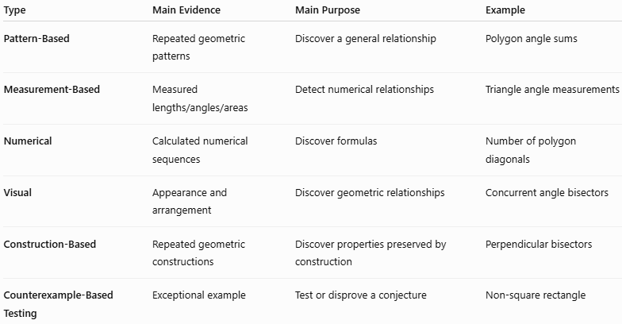
Type | Main Evidence | Main Purpose | Example
Pattern-Based | Repeated geometric patterns | Discover a general relationship | Polygon angle sums
Measurement-Based | Measured lengths/angles/areas | Detect numerical relationships | Triangle angle measurements
Numerical | Calculated numerical sequences | Discover formulas | Number of polygon diagonals
Visual | Appearance and arrangement | Discover geometric relationships | Concurrent angle bisectors
Construction-Based | Repeated geometric constructions | Discover properties preserved by construction | Perpendicular bisectors
Counterexample-Based Testing | Exceptional example | Test or disprove a conjecture | Non-square rectangle

Relationship Between the Types
# Source: AI Source: Provided by: [Data Path: Persons Table -> ID Column: 1, Name_En Column: Motasem Essam] -> From: [ChatGPT] on [7/25/2026]
These types frequently overlap.
For example, when discovering the number of diagonals in a polygon:
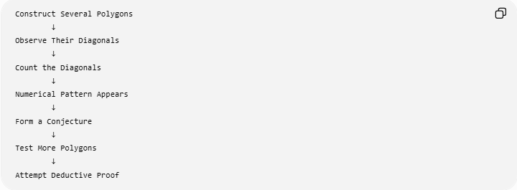
Construct Several Polygons
↓
Observe Their Diagonals
↓
Count the Diagonals
↓
Numerical Pattern Appears
↓
Form a Conjecture
↓
Test More Polygons
↓
Attempt Deductive Proof
This involves:
- Construction-Based reasoning — constructing polygons,
- Visual reasoning — observing the diagonals,
- Numerical reasoning — counting them,
- Pattern-Based reasoning — identifying the sequence,
- Counterexample-Based Testing — checking whether the conjecture fails.
Therefore, these categories are not mutually exclusive.

Inductive Reasoning and Conjectures
# Source: AI Source: Provided by: [Data Path: Persons Table -> ID Column: 1, Name_En Column: Motasem Essam] -> From: [ChatGPT] on [7/25/2026]
The central product of geometric inductive reasoning is a conjecture.
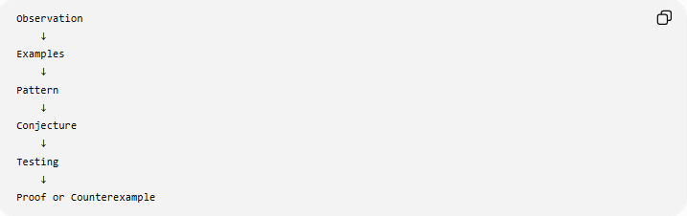
Observation
↓
Examples
↓
Pattern
↓
Conjecture
↓
Testing
↓
Proof or Counterexample
There are two possible outcomes:
Conjecture survives testing
It may then be investigated using deductive reasoning.
Conjecture fails
A counterexample shows that the conjecture is false and it must be rejected or modified.

Example: Sum of Interior Angles
# Source: AI Source: Provided by: [Data Path: Persons Table -> ID Column: 1, Name_En Column: Motasem Essam] -> From: [ChatGPT] on [7/25/2026]
Consider polygons.
Triangle
$$\left(3-2\right){180}^{∘}={180}^{∘}$$
Quadrilateral
$$\left(4-2\right){180}^{∘}={360}^{∘}$$
Pentagon
$$\left(5-2\right){180}^{∘}={540}^{∘}$$
Hexagon
$$\left(6-2\right){180}^{∘}={720}^{∘}$$
The pattern suggests:
$$\boxed{S=\left(n-2\right){180}^{∘}}$$
This is inductive reasoning because the general rule is discovered from specific cases.
The next step is deductive reasoning: prove that the formula holds for every appropriate $n$-sided polygon.

Example: Triangle Classification Pattern
# Source: AI Source: Provided by: [Data Path: Persons Table -> ID Column: 1, Name_En Column: Motasem Essam] -> From: [ChatGPT] on [7/25/2026]
Suppose several triangles are examined.
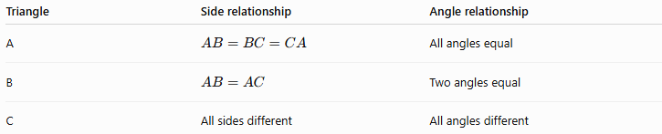
Triangle | Side relationship | Angle relationship
A | $$AB=BC=CA$$ | All angles equal
B | $$AB=AC$$ | Two angles equal
C | All sides different | All angles different
The observations suggest:
$$\boxed{\text{Equal sides are associated with equal opposite angles.}}$$
This can lead to the Isosceles Triangle Theorem and its converse, which can then be established through deductive proof.

Inductive Reasoning vs. Deductive Reasoning
# Source: AI Source: Provided by: [Data Path: Persons Table -> ID Column: 1, Name_En Column: Motasem Essam] -> From: [ChatGPT] on [7/25/2026]
The two forms of reasoning have different roles.
Inductive Reasoning
$$\boxed{\text{Examples}→\text{Pattern}→\text{Conjecture}}$$
Deductive Reasoning
$$\boxed{\text{Definitions/Principles}→\text{Logical Steps}→\text{Proof}}$$
A common mathematical workflow is:
$$\boxed{\text{Inductive Discovery}→\text{Conjecture}→\text{Deductive Proof}}$$
Example
- Measure several triangles.
- Notice that their angle sums are ${180}^{∘}$.
- Conjecture:
$$A+B+C={180}^{∘}$$
- Use geometric principles to prove the relationship.
- The statement becomes an established theorem.

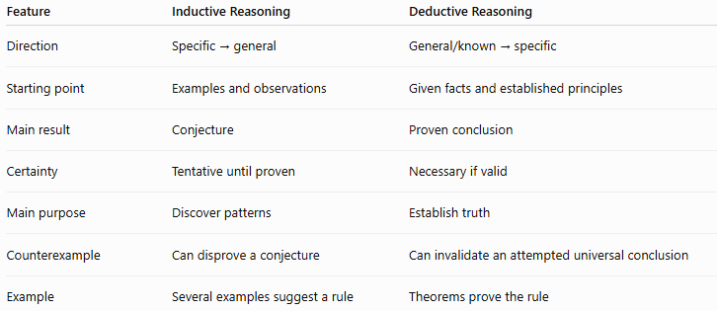
Feature | Inductive Reasoning | Deductive Reasoning
Direction | Specific → general | General/known → specific
Starting point | Examples and observations | Given facts and established principles
Main result | Conjecture | Proven conclusion
Certainty | Tentative until proven | Necessary if valid
Main purpose | Discover patterns | Establish truth
Counterexample | Can disprove a conjecture | Can invalidate an attempted universal conclusion
Example | Several examples suggest a rule | Theorems prove the rule
Relationship
$$\boxed{\text{Inductive Reasoning}→\text{Conjecture}→\text{Deductive Reasoning}→\text{Proof}}$$
This is an important relationship in mathematics.

Inductive Reasoning vs. Measurement
# Source: AI Source: Provided by: [Data Path: Persons Table -> ID Column: 1, Name_En Column: Motasem Essam] -> From: [ChatGPT] on [7/25/2026]
Measurement can be an important source of inductive evidence.
For example, measuring several circles may suggest:
$$\frac{C}{d}≈3.14159$$
This leads to the conjecture:
$$\boxed{\frac{C}{d}=π}$$
The measurements help discover the relationship, but the numerical observations themselves are not the mathematical definition or complete proof of the relationship.

Inductive Reasoning vs. Visual Observation
# Source: AI Source: Provided by: [Data Path: Persons Table -> ID Column: 1, Name_En Column: Motasem Essam] -> From: [ChatGPT] on [7/25/2026]
A diagram can reveal patterns, but visual appearance can be misleading.
For example, a quadrilateral may appear to have equal sides.
That does not establish:
$$AB=BC=CD=DA$$
unless the equality is given, constructed under appropriate conditions, measured as evidence, or logically proven.
Therefore:
$$\boxed{\text{Observation}→\text{Conjecture}}$$
not necessarily:
$$\boxed{\text{Observation}→\text{Proof}}$$

Important Distinction: Testing Is Not Proof
# Source: AI Source: Provided by: [Data Path: Persons Table -> ID Column: 1, Name_En Column: Motasem Essam] -> From: [ChatGPT] on [7/25/2026]
Suppose a conjecture works for:
$$10, 100, 1,000,\text{ or even }1,000,000$$
examples.
That does not necessarily establish that it works for every possible geometric case.
Therefore:
$$\boxed{\text{Successful Examples}≠\text{Universal Proof}}$$
However:
$$\boxed{\text{One Valid Counterexample}⇒\text{Universal Conjecture is False}}$$
This asymmetry is one of the most important features of inductive reasoning.

Role of Counterexamples
# Source: AI Source: Provided by: [Data Path: Persons Table -> ID Column: 1, Name_En Column: Motasem Essam] -> From: [ChatGPT] on [7/25/2026]
Counterexamples are especially important in inductive reasoning.
Suppose the conjecture is:
All rectangles are squares.
Consider a rectangle with:
$$L=8, W=4$$
Since:
$$L≠W$$
it is a rectangle but not a square.
Therefore:
$$\boxed{\text{The conjecture is false.}}$$
A single valid counterexample is enough to disprove a universal statement.

Limitations of Inductive Reasoning
# Source: AI Source: Provided by: [Data Path: Persons Table -> ID Column: 1, Name_En Column: Motasem Essam] -> From: [ChatGPT] on [7/25/2026]
Inductive reasoning is powerful for discovering mathematical relationships, but it has limitations.
1. A pattern may eventually fail
Several examples may follow a pattern even though the generalization is false.
2. Measurements have limited precision
Small measurement errors can create misleading patterns.
3. Diagrams may be misleading
A figure is not necessarily drawn to scale.
4. Finite examples cannot normally establish a universal geometric theorem
Even a very large number of successful examples does not automatically prove that the statement is true for every possible case.
Therefore:
$$\boxed{\text{Many examples}≠\text{Universal proof}}$$

Inductive Reasoning Process
# Source: AI Source: Provided by: [Data Path: Persons Table -> ID Column: 1, Name_En Column: Motasem Essam] -> From: [ChatGPT] on [7/25/2026]
A practical procedure is:
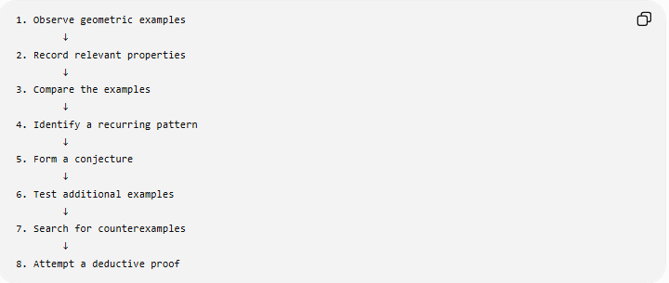
1. Observe geometric examples
↓
2. Record relevant properties
↓
3. Compare the examples
↓
4. Identify a recurring pattern
↓
5. Form a conjecture
↓
6. Test additional examples
↓
7. Search for counterexamples
↓
8. Attempt a deductive proof

Classification Summary
# Source: AI Source: Provided by: [Data Path: Persons Table -> ID Column: 1, Name_En Column: Motasem Essam] -> From: [ChatGPT] on [7/25/2026]
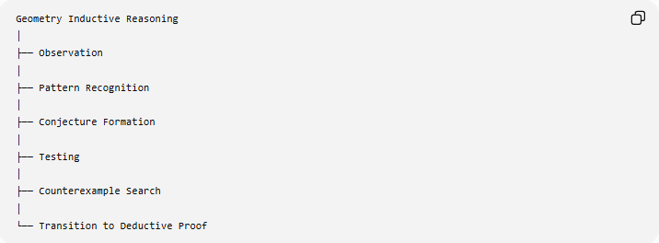
Geometry Inductive Reasoning
│
├── Observation
│
├── Pattern Recognition
│
├── Conjecture Formation
│
├── Testing
│
├── Counterexample Search
│
└── Transition to Deductive Proof
By practical method:
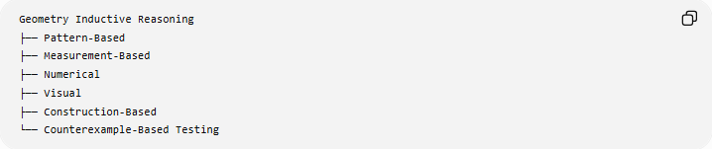
Geometry Inductive Reasoning
├── Pattern-Based
├── Measurement-Based
├── Numerical
├── Visual
├── Construction-Based
└── Counterexample-Based Testing
These are practical categories rather than universally standardized formal types.

Key Points
# Source: AI Source: Provided by: [Data Path: Persons Table -> ID Column: 1, Name_En Column: Motasem Essam] -> From: [ChatGPT] on [7/25/2026]
- Inductive reasoning moves from specific observations toward a general conjecture.
- Its main purpose in geometry is often pattern discovery.
- A conjecture is a proposed statement based on observed evidence.
- Testing additional examples can strengthen confidence in a conjecture.
- A single valid counterexample can disprove a universal conjecture.
- Measurement and diagrams can provide evidence but do not generally replace proof.
- Inductive reasoning does not normally establish universal mathematical certainty by itself.
- Deductive reasoning is used to formally establish a conjecture.
- Inductive and deductive reasoning therefore complement each other.
- A common mathematical cycle is:
$$\boxed{\text{Observe}→\text{Pattern}→\text{Conjecture}→\text{Test}→\text{Prove or Reject}}$$

Conclusion
# Source: AI Source: Provided by: [Data Path: Persons Table -> ID Column: 1, Name_En Column: Motasem Essam] -> From: [ChatGPT] on [7/25/2026]
Geometry Inductive Reasoning is the process of examining specific geometric examples, identifying patterns, and using those patterns to formulate conjectures. It is especially useful for discovering geometric relationships and suggesting new theorems.
Its relationship with deductive reasoning can be summarized as:
$$\boxed{\text{Inductive Reasoning discovers what may be true}} \\ \boxed{\text{Deductive Reasoning establishes why it must be true}}$$
Thus, inductive reasoning is an important discovery tool in geometry, while deductive reasoning provides the formal mathematical justification.

